Top of Form

Question **1**

Complete

Mark 1.00 out of 1.00

Flag question

Question text

Please refer to Figure 2 to answer the question below:

The error in Figure 2 is _______.

Select one:

a. “tralse”;

b. no error

c. case “me”:

d. pStr

e. switch(str)

Question **2**

Complete

Mark 1.00 out of 1.00

Flag question

Question text

Switches are always used with if-else statements

Select one:

a. True

b. False

Question **3**

Complete

Mark 1.00 out of 1.00

Flag question

Question text

x+1 is example of a statement.

Select one:

a. True

b. False

Question **4**

Complete

Mark 1.00 out of 1.00

Flag question

Question text

If statements cannot be nested in switches

Select one:

a. True

b. False

Question **5**

Complete

Mark 1.00 out of 1.00

Flag question

Question text

“||” and “&&” can be used in conditional statements.

Select one:

a. True

b. False

Question **6**

Complete

Mark 1.00 out of 1.00

Flag question

Question text

number++; is an expression

Select one:

a. False

b. True

Question **7**

Complete

Mark 1.00 out of 1.00

Flag question

Question text

Among the statements below which is only an expression

Select one:

a. “string1” + “string2”

b. system.in.read( );

c. true;

d. bool

e. System.out.println(“Hi!”);

Question **8**

Complete

Mark 1.00 out of 1.00

Flag question

Question text

Expressions are like clauses.

Select one:

a. False

b. True

Question **9**

Complete

Mark 1.00 out of 1.00

Flag question

Question text

Switches can work properly even without the “break” expression.

Select one:

a. True

b. False

Question **10**

Complete

Mark 1.00 out of 1.00

Flag question

Question text

Expressions can be long and complex.

Select one:

a. False

b. True

|  |  |
| --- | --- |
| **Started on** | Thursday, 24 September 2020, 2:20 AM |
| **State** | Finished |
| **Completed on** | Thursday, 24 September 2020, 2:21 AM |
| **Time taken** | 1 min 35 secs |
| **Grade** | **10.00** out of 10.00 (**100**%) |

Top of Form

Question **1**

Complete

Mark 1.00 out of 1.00

Flag question

Question text

Conditional test expressions can contain declarations

Select one:

a. True

Question **2**

Complete

Mark 1.00 out of 1.00

Flag question

Question text

Please refer to figure 1 to answer the question below:

The test expression of the if statement is _______

Select one:

b. less than equal to

Question **3**

Complete

Mark 1.00 out of 1.00

Flag question

Question text

Statements can be expressions.

Select one:

a. False

Question **4**

Complete

Mark 1.00 out of 1.00

Flag question

Question text

Blocks can be one liner or huge classes.

Select one:

b. True

Question **5**

Complete

Mark 1.00 out of 1.00

Flag question

Question text

Please refer to figure 1 to answer the question below: In figure 1 if(x==5) is _______.

Select one:

c. skipped

Question **6**

Complete

Mark 1.00 out of 1.00

Flag question

Question text

For-loops can be nested in while loops.

Select one:

b. True

Question **7**

Complete

Mark 1.00 out of 1.00

Flag question

Question text

Expressions can be statements.

Select one:

b. True

Question **8**

Complete

Mark 1.00 out of 1.00

Flag question

Question text

For-loops has a set number of iterations before starting.

Select one:

a. True

Question **9**

Complete

Mark 1.00 out of 1.00

Flag question

Question text

While loops can use Booleans at test expressions.

Select one:

b. True

Question **10**

Complete

Mark 1.00 out of 1.00

Flag question

Question text

Please refer to Figure 2 to answer the question below: If the expression “num = 0” is changed to “num = 5” the final output will be _______.

Select one:

b. 5



Bottom of Form

|  |  |
| --- | --- |
| **Started on** | Thursday, 24 September 2020, 2:24 AM |
| **State** | Finished |
| **Completed on** | Thursday, 24 September 2020, 2:39 AM |
| **Time taken** | 14 mins 59 secs |
| **Grade** | **10.00** out of 10.00 (**100**%) |

Top of Form

Question **1**

Complete

Mark 1.00 out of 1.00

Flag question

Question text

True or False: The conditional AND operator uses two ampersand (&&) symbols.

Answer: 

Question **2**

Complete

Mark 1.00 out of 1.00

Flag question

Question text

**Observe the following statements and decide whether the variable result’s value is TRUE or FALSE.**

**Given that:**

**int x = -77;**

**int z = 43;**

result = (z < x && 1 != 10) ? true : false;

result = (x * z + (z += 7)) >= 100;

Select one:

False

Question **3**

Complete

Mark 1.00 out of 1.00

Flag question

Question text

Refer to the program below. Read each statement carefully and write the output for each line specified.

Line 15 will display on the screen.

Question **4**

Complete

Mark 1.00 out of 1.00

Flag question

Question text

Refer to the program below. Read each statement carefully and write the output for each line specified.

Line 13 will display on the screen.

Question **5**

Complete

Mark 1.00 out of 1.00

Flag question

Question text

Refer to the block of codes below. Read each statement carefully and decide whether it’s TRUE or FALSE.

There is an error in line 9.

Answer: 

Question **6**

Complete

Mark 1.00 out of 1.00

Flag question

Question text

True or False: Brackets [] are also separators used in declaring [arrays](https://shs.amaesonline.com/batch1/mod/page/view.php?id=317).

Answer: 

Question **7**

Complete

Mark 1.00 out of 1.00

Flag question

Question text

Refer to the block of codes below. Read each statement carefully and decide whether it’s TRUE or FALSE.

There are keywords found in line 7.

Answer: 

Question **8**

Complete

Mark 1.00 out of 1.00

Flag question

Question text

Refer to the block of codes below. Read each statement carefully and decide whether it’s TRUE or FALSE.

There are also punctuators used in line 10, in between System, out and println, the parentheses and semicolon.

Answer: 

Question **9**

Complete

Mark 1.00 out of 1.00

Flag question

Question text

**Observe the following statements and decide whether the variable result’s value is TRUE or FALSE.**

**Given that:**

**int x = -77;**

**int z = 43;**

result = (z < x && 1 != 10) ? true : false;

result = (z != 43) ? true : false;

Select one:

False

Question **10**

Complete

Mark 1.00 out of 1.00

Flag question

Question text

True or False: Identifiers in Java are, in simple words, name that you give to Java class, variables and methods.

Answer: 

Bottom of Form

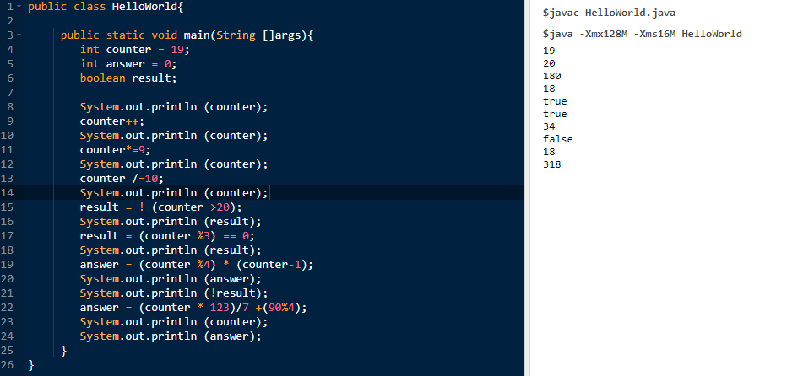

|  |  |
| --- | --- |
| **Started on** | Thursday, 24 September 2020, 10:11 AM |
| **State** | Finished |
| **Completed on** | Thursday, 24 September 2020, 10:14 AM |
| **Time taken** | 2 mins 31 secs |
| **Grade** | **10.00** out of 10.00 (**100**%) |

Top of Form

Question **1**

Complete

Mark 1.00 out of 1.00

Flag question

Question text

When polymorphism is used, the Java object can only take one form. Subclasses should have the same function with the parent class.

Select one:

a. False

Question **2**

Complete

Mark 1.00 out of 1.00

Flag question

Question text

_________ is also known as a parent class.

Select one:

j. Super class

Question **3**

Complete

Mark 1.00 out of 1.00

Flag question

Question text

________ is one of the four fundamental concepts, this is also known as data hiding.

Select one:

c. Encapsulation

Question **4**

Complete

Mark 1.00 out of 1.00

Flag question

Question text

Declaring an object in Java uses the new keyword to create a new object.

Select one:

b. False

Question **5**

Complete

Mark 1.00 out of 1.00

Flag question

Question text

A child class inherits all the methods of every other class.

Select one:

a. False

Question **6**

Complete

Mark 1.00 out of 1.00

Flag question

Question text

Inherited fields and methods can be used _______ by child classes.

Select one:

c. Directly

Question **7**

Complete

Mark 1.00 out of 1.00

Flag question

Question text

A polymorphic object can pass more than one Is-a test.

Select one:

a. True

Question **8**

Complete

Mark 1.00 out of 1.00

Flag question

Question text

Variables must be declared as _______ for it to be fully hidden.

Select one:

i. Private

Question **9**

Complete

Mark 1.00 out of 1.00

Flag question

Question text

Abstraction works by hiding the implementation details and showing only the functions necessary.

Select one:

b. True

Question **10**

Complete

Mark 1.00 out of 1.00

Flag question

Question text

Polymorphic objects can pass ________ Is-a test.

Select one:

b. More than one